React Native Skia: High-Performance Graphics for React Native

## **Overview**

**React Native Skia** is a powerful 2D graphics engine brought to React Native by Shopify. It allows developers to render custom visuals with low latency and high frame rates, similar to what’s possible in native apps or Flutter.

Skia is the same graphics engine used by:

* Google Chrome
* Android OS
* Flutter

This means React Native apps can now support advanced drawing, animation, and visual effects natively and smoothly.

## **1. Powerful 2D Graphics Rendering Engine**

React Native Skia gives you full control over the canvas for drawing shapes, paths, gradients, text, and more.

### **✅ Key Capabilities:**

* Drawing primitives: lines, circles, rectangles, paths.
* Advanced paint styles: gradients, shadows, strokes.
* Layers and canvas transforms (rotate, scale).
* Custom render loops and frame control.

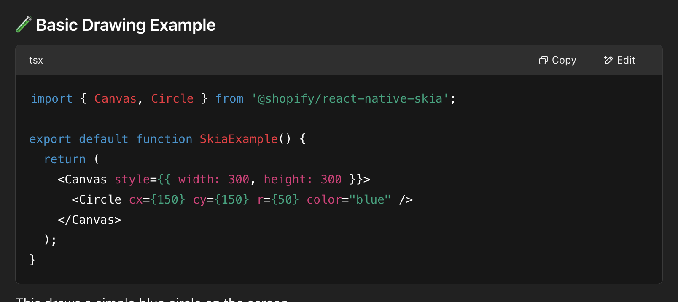

## **2. Enables High-Performance Animations and UI Effects**

Unlike the traditional React Native rendering model, Skia draws directly on the canvas using the GPU, bypassing native view managers. This makes it ideal for high-performance visual elements.

### **🎯 Use Cases:**

* Custom loaders and spinners.
* Animated charts, graphs, and gauges.
* Touch-responsive elements.
* Blurs, shaders, and visual filters.

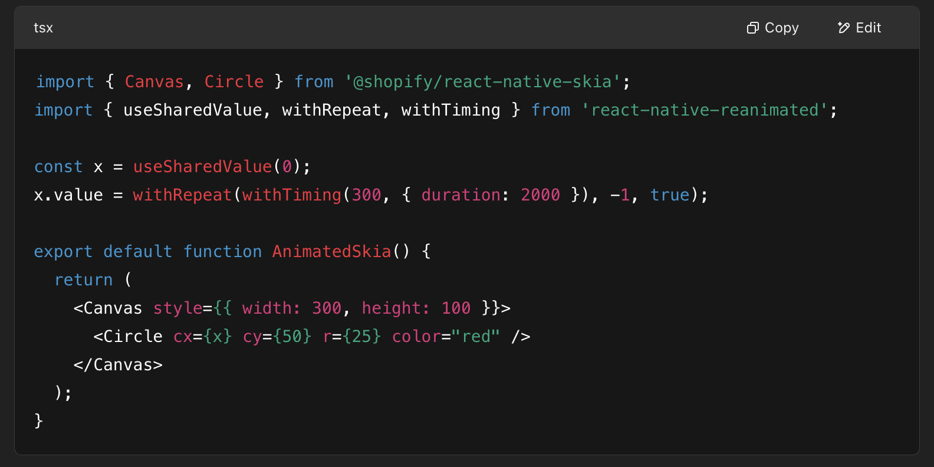

## **3. Seamless Integration with Reanimated 3**

React Native Skia works natively with **Reanimated 3**, using **shared values** and **worklets** to drive animations efficiently on the UI thread.

